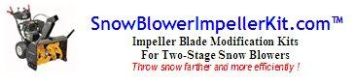 | Snow Blower Impeller Kit™  Modifies Two-stage snow blowers  For Kit Model #s  (1/4”) SBIK141,143,144,145,146  (3/8”) SBIK381,383,384,385,386
The Problem:
If your TWO-STAGE snow blower’s discharge chute keeps clogging up when you try to move very heavy or wet snow or slush, it is probably because of a large gap or space between the impeller blades (the 2nd set of vertical blades behind the main front horizontal auger blades) and the cylindrical chamber in which it rotates. This "gap" allows snow and slush to slip by the blades and build up around the impeller and in the discharge chute clogging it. This gap also decreases the efficiency of the impeller's ability to propel the snow up the chute resulting in less throwing distance. This problem is well known to people with two-stage snow blowers, and the easy and the quick, inexpensive fix is to modify the impeller blades by adding a strip of reinforced rubber to each one of them to eliminate this gap. It is HIGHLY recommended that you install a Snow Blower Impeller Kit™ on each blade however, because only modifying some but not all of the blades will cause a harmonic imbalance in the spinning impeller which could easily cause excessive wear on the impeller shaft bearing resulting in very costly repairs! If you have a single-stage snow blower, or your gap is less than 1/4" or greater than 5/8", you probably don't need or can't use this fix.
The Solution:
Install this Snow Blower Impeller Kit™ on to your two-stage snow blower and never fear another snow fall again!
- Virtually eliminate the “clogged chute” syndrome when moving wet or heavy snow!
- Dramatically increase the snow throwing distance of your snow blower!
- Depending on how handy you are, this kit can be installed in 1-2 hours without too much difficulty!
- LifeTime Guarantee! If you are ever dissatisfied with our product, you can return it for a full refund of your purchase price!
*You can easily make an extra $50-$100 by modifying your friends, neighbors and relative's snow blowers with this kit.
 | Each Snow Blower Impeller Kit™ contains the following Top Quality, "Made in the USA" materials:  - (1) 1/4” or 3/8” thick rubber paddle (2"W x 5"L) - (you trim to fit as needed)  - Made from Styrene Butadiene rubber (SBR rubber)  - SBR rubber with minimum tensile strength of 725 PSI (5 MPA)  - Hard rubber with a durometer of 65-75  - (1) metal strap with holes - 1 3/8" W x 3 3/4"L  - Punched flat bar grade 5 steel, 1/16" thick  - (3) bolts (5/16-18 x 1 in. coarse thread) w/ 5/16-18 lock nuts (use 1/2" wrench & socket)  - Hex bolts & Hex lock nuts nylon insert, grade 5 steel  - (1) self-tapping screw (#14 x 1) (not shown in picture to right)  - Sheet metal screw, Hex washer head self drilling, grade 5 steel  - Instruction Sheet & FAQs |  | 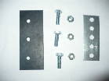  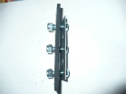
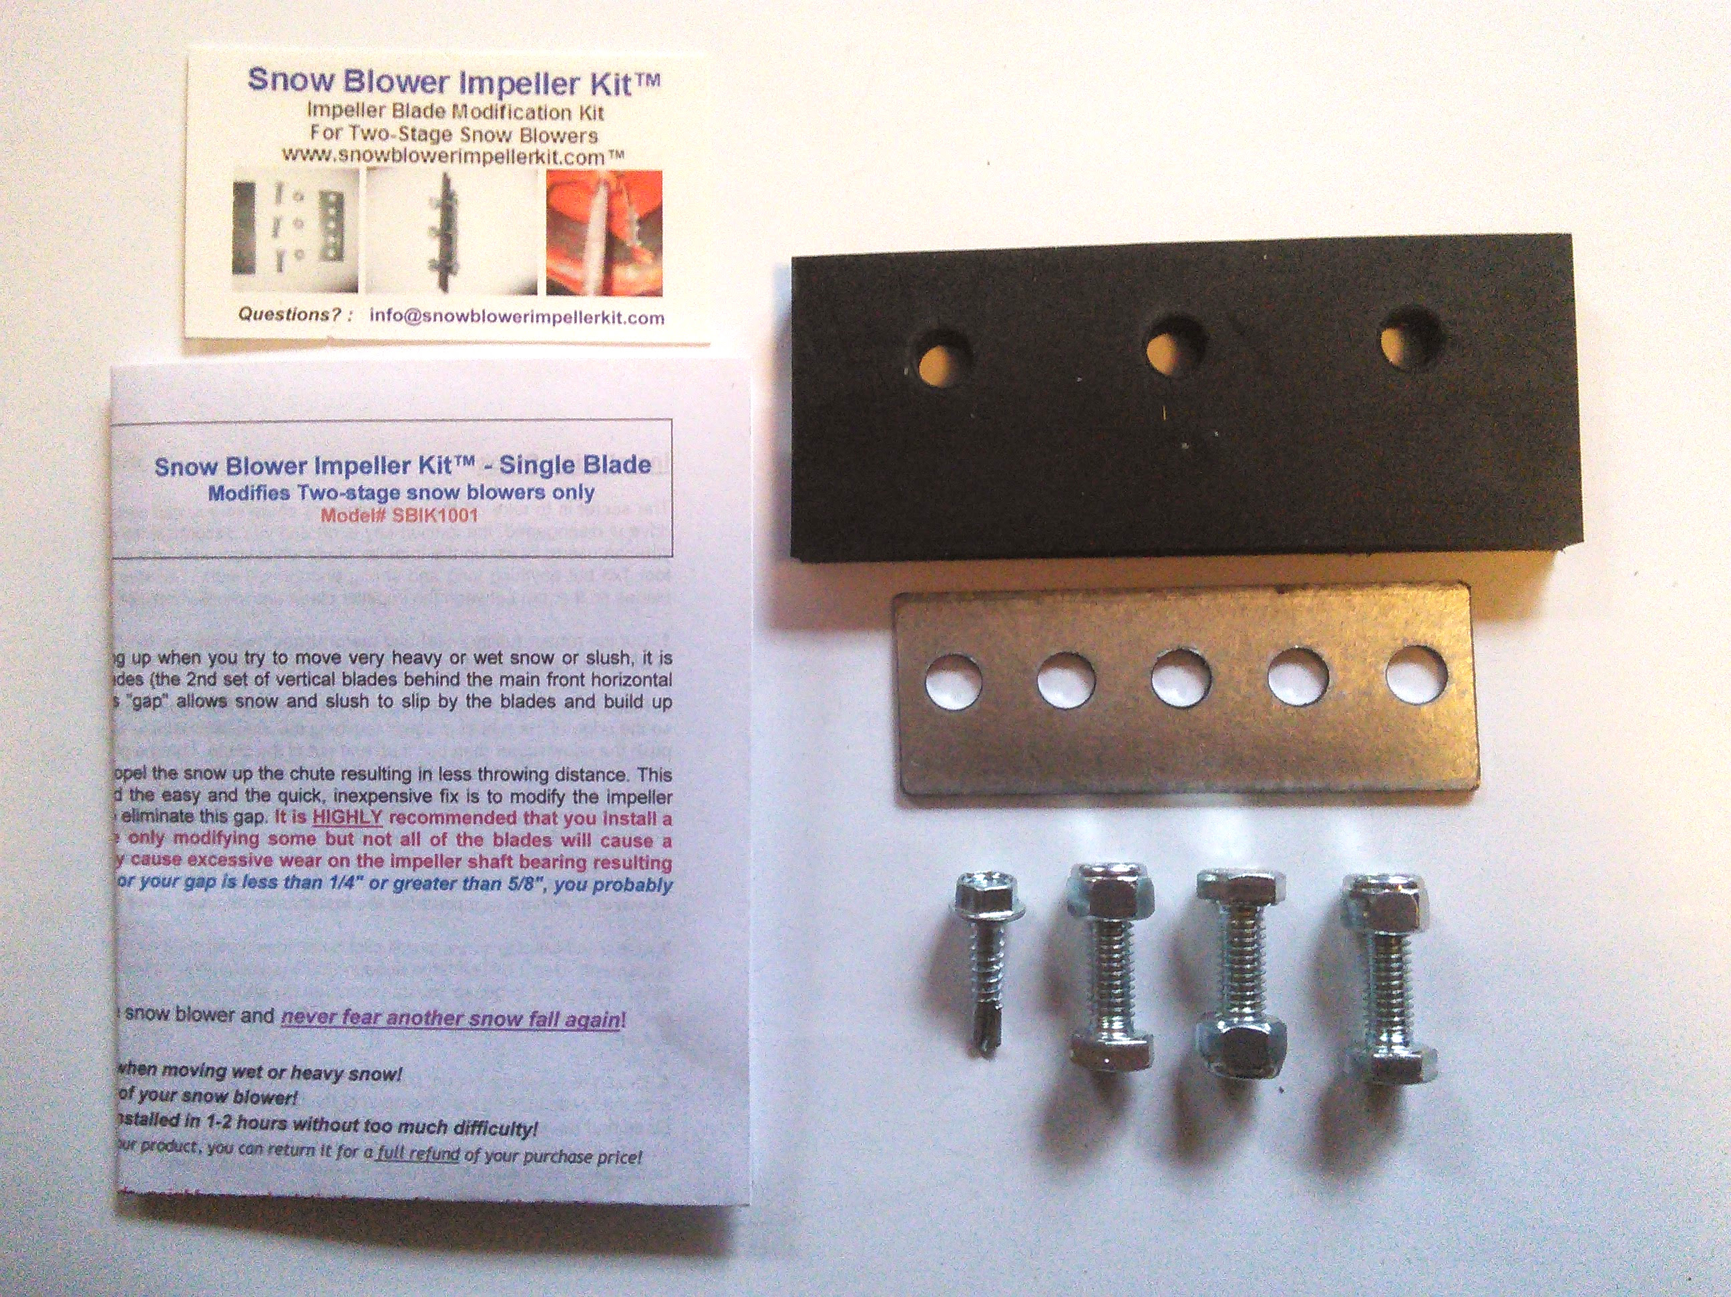 |  | Materials required for installation include:  Two-Stage Snow Blowers require (1) Snow Blower Impeller Kit™ for every impeller blade. 1/3/4/5/6 Blade Kits available to meet your needs!  * Corded drill w/3/8” pilot point drill bit. (Cordless drills are not powerful enough)  * 4-6” drill bit extension w/ ½” scoket (for self-tapping screws)  * a little bit of oil to lubricate drill bit tip while drilling  * ratchet set w/1/2” socket , ½” open end wrench and 3’ brace of some kind (like a 1x3)  * utility knife, hacksaw (if necessary)  * not included in kit  Make sure you read our FAQs and review our drawing of installed kit prior to installation!

To see real-life examples of this modification before you attempt this on your own snow blower, go to YouTube.com, search for “Snow Blower Impeller Kit™” or some variation on this theme and watch the videos. You will be amazed at what you see!

Installation Steps: (intallation steps are the same for all SBIKits...Read our FAQ before beginning install)
The secret is to take off the snow blower’s chute so you can easily reach each impeller blade (for safety sake, make sure the auger drive is disengaged, the ignition key is off and you disconnect the spark plug first). Get something to stick through the front auger that you can use to brace up the impeller blade while you work on it because you will be pushing down on it with the drill. You can use a 3 foot 1x3 but anything long and strong enough will work. The idea of course is to afix the rubber and backing brace onto the impeller blades so the gap between the impeller blade and impeller chamber wall is negated.

1. Cut the rubber (utility knife) and metal straps (hacksaw) to “length” if necessary. “Length” is the flat part of the impeller blade on the “TOP” side, up to but not including the curl on the blade. The “TOP” side is the side where the blade curls up.

2. Place the rubber and metal brace in place on the TOP side (impeller spins clockwise when standing at controls) of the impeller blade so the edge of the rubber barely scrapes the impeller chamber wall (See Figure A & B). You want the rubber on the top side so it will push the snow rather than pull it up and out of the chute. Using a grease pencil or marker, mark the hole locations on the impeller blade where you will be drilling. Hint: make sure the drilled holes will not interfere with the impeller blade's underside supporting bracket and that you will be able to securely attach a lock nut to the bolt through the blade! Feel free to position the metal "back plate" so you can do so.
The most important thing is to make sure the rubber barely scrapes the side-wall of the impeller chamber wall if at all. Note: inspect the impeller chamber for any obstructions (like bolt heads, metal lips, etc.) that might interfere with the passage of the rubber paddles and adjust the paddle installation to avoid them if necessary. It doesn't really matter if the "back plate" is completely parallel with the rubber strip because once it's bolted down, the rubber's not going anywhere, and it will “wear in” parallel anyway. If the impeller blade’s underside supporting bracket will get in the way of a bolt, you can use a self-tapping screw in its place though this is not as secure as a bolt and we do not recommend it unless absolutely necessary. If you choose to do this, do so at your own risk!

3. Use a self-tapping screw to drill pilot holes (use included metal strap held in place with small spring clamps as template) which then can be drilled out for the bolts for permanent placement. Use a drill bit large enough (3/8”) to accommodate the bolts. Stick a brace lever (like the three foot 1x3 mentioned above) through the front auger so you can brace up the impeller blade while you drill down on it. Hint: Dip the drill bit’s tip into oil each time before you drill into the impeller blade. This will reduce friction and resulting heat buildup on the bit’s tip and make the drilling go easier!
4. Once the holes are drilled, position the rubber strip with the metal back brace on the top side of the impeller blade and bolt it securely onto the blade making sure the edge of the rubber barely touches the impeller chamber wall (See Figure A & B). Repeat for each impeller blade and do ALL of the blades. If you do not do ALL of the blades it WILL affect the harmonic balance of the impeller and eventually cause a bearing failure in the impeller shaft which is a big dollar repair job! Hint: After each blade install, hand rotate impeller (completely around the inside of the impeller chamber to check fit and adjust if necessary before proceeding on to next blade install.

5. Re-attach the chute to the snow blower, reconnect spark plug, put away your tools and clean up. The whole job should take you between 1-2 hours depending on how handy you are.

The end result should look like this:
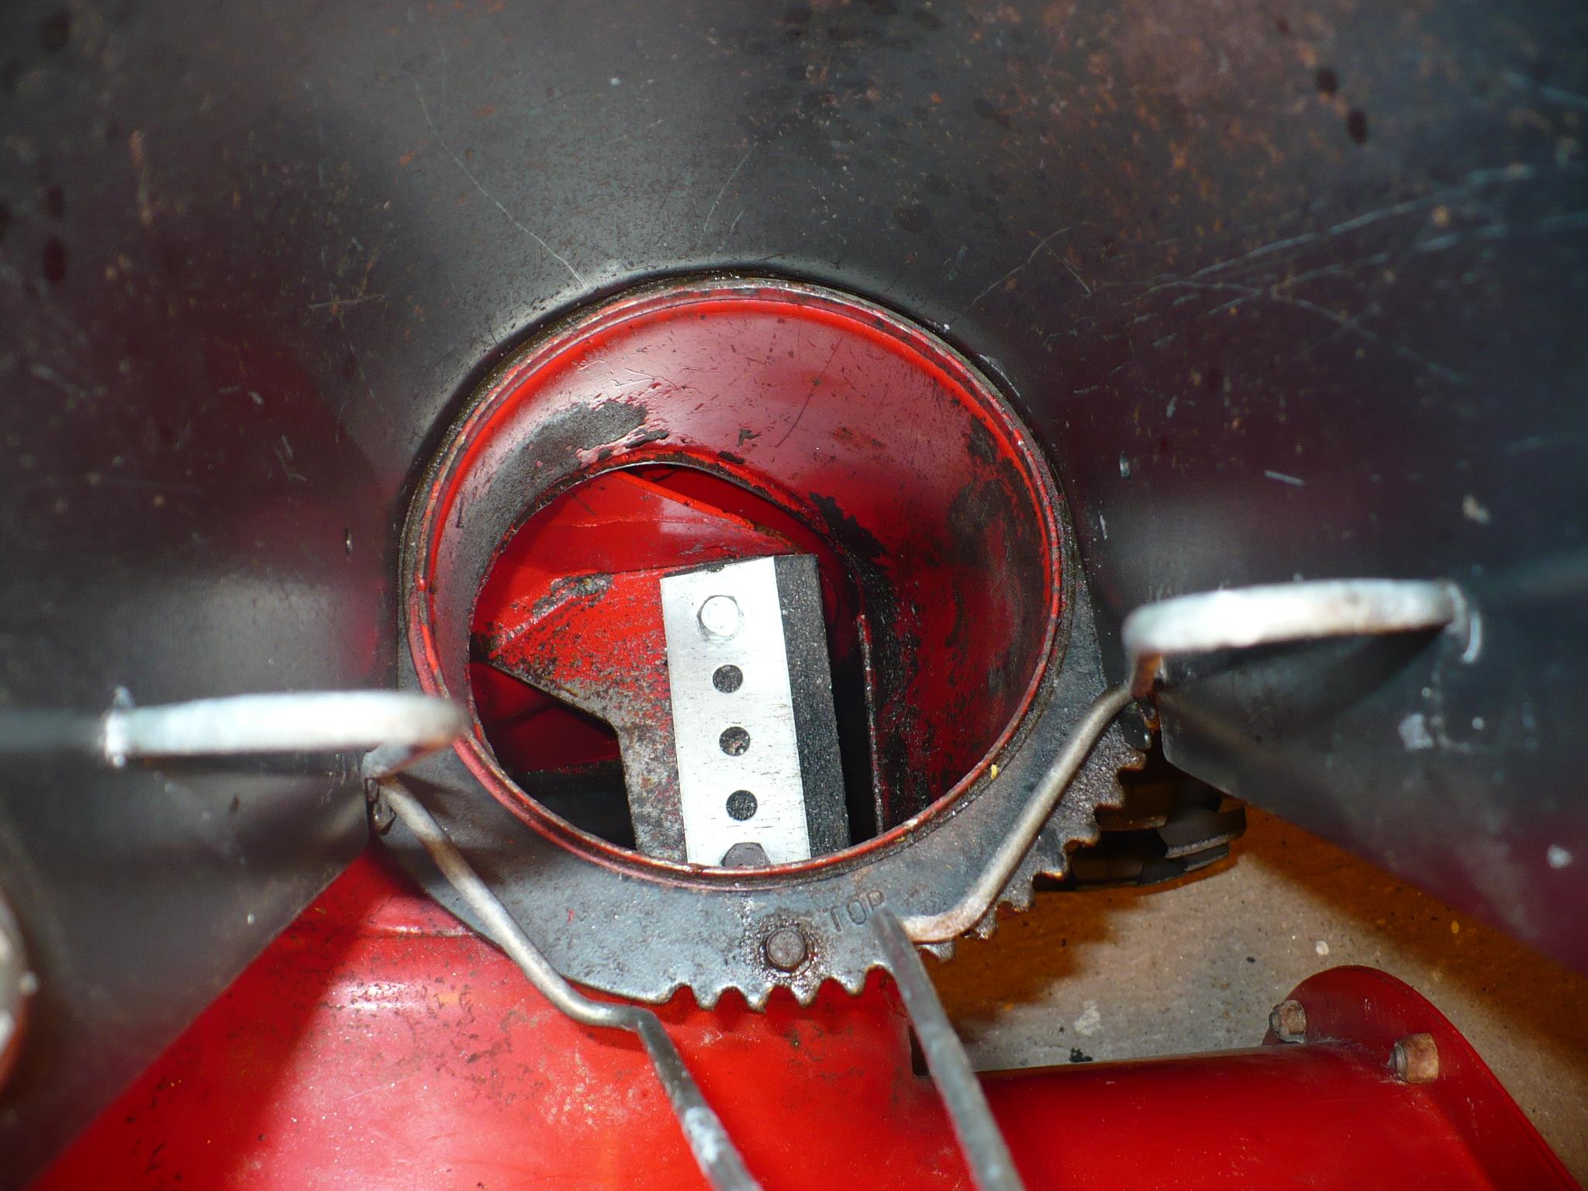  Figure A | 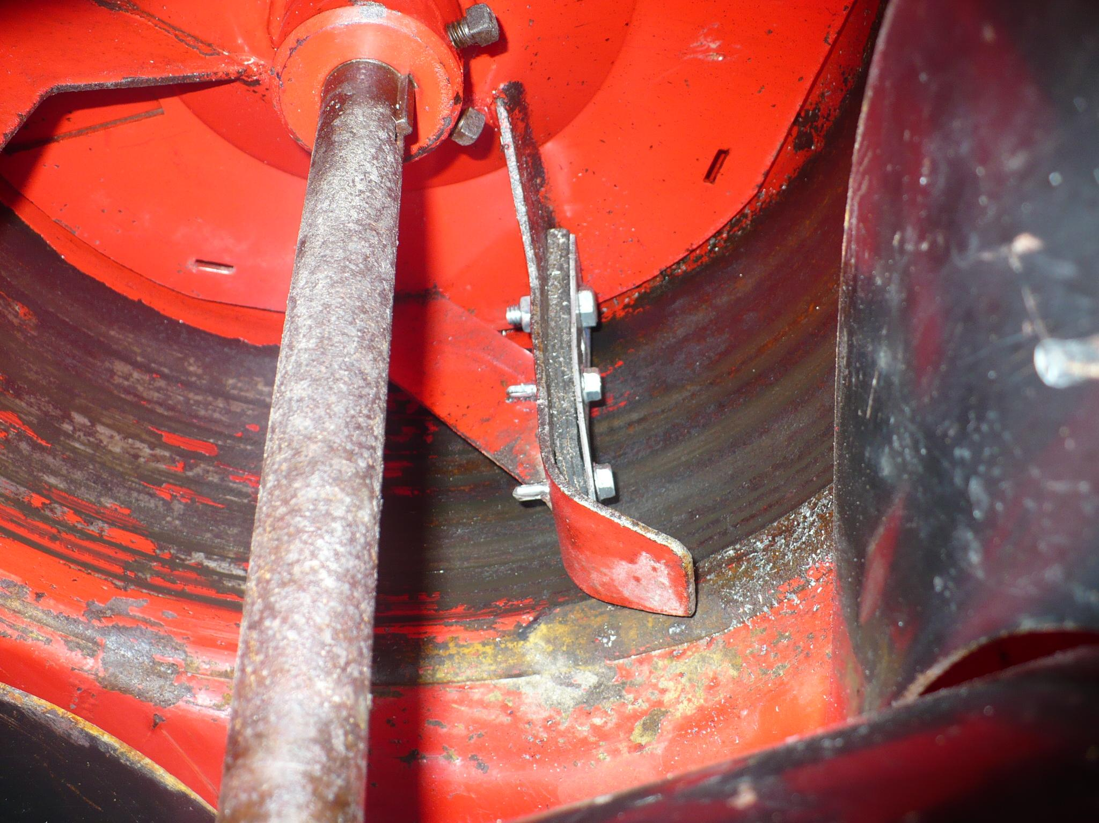  Figure B | Liability Disclaimer: At no time shall the manufacturer be held liable for any consequences, either direct or indirect, resulting from the purchase, installation or use of any product purchased from manufacturer. Manufacturer makes no warranty or guarantees, either expressed or implied, as to the specific results obtained through the installation of our products. Buyer agrees to purchase and use this product at their own risk. Customization made to this kit by the buyer will void the warranty & guarantee unless manufacturer advises and approves of proper customization procedure in writing prior to installation, or manufacturer customizes the kit to the buyer's written and approved specifications prior to shipping.

When the installation is complete, run your snow blower with the auger engaged for a couple of minutes to wear off any excess rubber and ensure a smooth fit. Do not worry about any increased load on the motor as the rubber wears in, it is negligible and will not compromise the motor in any way. If you do experience any auger slippage when trying to move snow, it’s most likely the auger belt which is slipping and needs either adjustment or replacement. That’s it!

When that's done, your snow blower will be all set to throw anything, farther and more efficiently without clogging up!

By the way, you may be asking yourself why the manufacturers leave a gap between the impeller blades and the impeller chamber wall. The reason is that the impeller shaft bearing wears over time and this wear causes some degree of “wobble” in the impeller’s rotation. They leave a gap to accommodate this “wobble” if/when it happens and avoid a situation where you have metal scraping on metal which could cause significant damage to the impeller chamber wall and to the impeller itself. Since this modification uses rubber strips which wear down as they come in contact with the impeller chamber wall, any possible future “wobble” in the impeller’s rotation is negated without compromising the snow blower’s operational integrity or efficiency at moving snow and slush.

Thank You For Your Order! If you need more kits, go to our website at http://www.snowblowerimpellerkit.com™ or find us on EBay by searching for “Snow Blower Impeller Kit™”
© 2012 SnowBlowerImpellerKit.com™ All Rights Reserved Questions? Contact us at: info@SnowBlowerImpellerKit.com
Snow Blower Impeller Kit™ Reg. USPTO Read our FAQs on SnowBlowerImpellerKit.com

SnowBlowerImpellerKit .com™ FAQs

Q- What is the purpose of the Snow Blower Impeller Kit ™?
A- This kit reduces the existing “gap” between the snow blower's impeller blades and the impeller chamber wall. The smaller the gap, the greater your machine's operational efficiency and snow throwing capability will be, and the less likely that your machine will clog up with snow.
Q- Why would I want to install this?
A- If the existing “gap” on your machine is between 1/4” & 5/8” or greater, then your machine is losing a significant amount of efficiency and power in throwing snow. This loss in efficiency results in more clogging in your discharge chute, and less throwing distance. As with any impeller device (snow blower, water pump, etc.), simple physics proves that maximum efficiency is achieved when there is no gap between the impeller's blades and the impeller chamber's walls. Some newer, more powerful snow blowers might have a significant gap but still work fine, so the bottom line is this...Are you happy with your snow blower's performance? For any excellent explanation on this subject, watch Ari P's. Excellent YouTube video on our website (thanks for allowing us to share this Ari!)
Q- Why don't the manufacturers eliminate this gap from their machines?
A-The reason is that on machines with straight shaft mounted impellers (which most are) the impeller’s bearing wears over time and this wear causes some degree of “wobble” in the impeller’s rotation. If the metal impeller blade was made to fit "flush" against the metal cylinder walls with no gap, there would be no tolerance for "rotational wobble". They leave this gap to accommodate this “wobble” if/when it happens and avoid a situation where you have metal scraping on metal. That could cause significant damage to the impeller and the cylinder walls in which it rotates requiring very expensive repairs. Since this modification uses rubber paddles which wear down evenly as they come in contact with the cylinder walls, any possible future “wobble” in the impeller’s rotation is negated without compromising the snow blower’s operational integrity or efficiency at moving snow and slush.
Q- If I install your Snow Blower Impeller Kit ™, will it eliminate all clogging?
A- Theoretically, yes, but the reality is that it depends on a number of things. Snow conditions, engine displacement, torque output, etc. For example, snow that has a water consistency of 40% or more (slush) can turn into ice in your snow blower's discharge chute and clog the chute regardless of your machine's output capability. This kit reduces the likelihood of that happening but nothing can prevent that completely.
Q- Does engine size really matter?
A- In most cases, Yes, however don't confuse engine size (whether rated in HP or CCs) with the ability to move snow efficiently. Sure, a 10HP or 305CC engine has more potential power than a 5HP or 271 CC engine, but the power output and ability to move snow is much more dependent on impeller revolutions and torque than just engine size. The faster your impeller spins and the larger your machine's “foot pounds of torque” performance specification is, the greater its' ability to power through snow of any consistency. Where the engine size is most important is in it's ability to handle an increasing “load” without stalling. It is a misconception that all 10HP or 305CC machines are the same, because they might have different torque ratings or revolutions per minute.
Here's an approximate conversion chart courtesy of MovingSnow.com
123 cc = 4 hp  179 cc = 5 hp  208 cc = 8 to 9 Gross Torque = 5.5 to 6 hp  277 cc = 11 to 11.5 Gross Torque = 7 to 8 hp | 305 cc = 13.5 to 14.5 Gross Torque = 9 to 10 hp  342 cc = 15.5 to 16.5 Gross Torque = 11 to 12 hp  357 cc = 14 hp  420 cc = 15 hp
Q- What exactly is a Snow Blower Impeller Kit ™?
A- This kit contains all of the materials necessary to modify ONE snow blower impeller blade.
Q- Where are the materials in the kit made?
A-Each Snow Blower Impeller Kit™ contains Top Quality, "Made in the USA" materials.
Q- What type of rubber paddles do you use?
A- Our paddles are made of Styrene Butadiene Rubber (SBR) Shore-A rubber with a durometer of 65-75 and minimum tensile strength of 725 PSI (5 MPA). For more info, click on “Description” menu item on our website.
Q- Why would I ever order a single-blade kit?
A- You might want a spare kit, or maybe you previously ordered a Three-Blade kit and later realized you really needed a Four-Blade kit.
Q- I need to modify all of my snow blower's impeller blades, do I need to buy a single blade kit for each of my machine's blades?
A- No, we offer a Three, Four, Five and Six Blade kits in both 1/4" thick and 3/8" thick rubber paddle configurations as well. Each of these contains all of the materials necessary to modify that number of impeller blades in your machine. For example, if your two-stage snowblower has three impeller blades, you can order either the Three-Blade kit, or the Four Blade kit and keep the extra set as a spare.
Q- Why do you offer kits with rubber paddles in both 1/4" and 3/8" thick configurations?
A- There are many different configurations of snow blowers in operation, and many different conditions under which they operate. We offer these two configurations so you can choose which kit best fits your particular needs.
Q- Can I install this kit on a two-stage snow blower with plastic impeller blades?
A- We have never sold this kit to anyone with plastic impeller blades because it is intended to be mounted on metal blades. I'm sorry but we just do not know if it would work, or if your plastic impeller blades would crack during installation or break during use because the drilled bolt holes have weakened the blades too much to handle the stress. Of course, we do not know that the kit wouldn't work as advertised either but quite honestly, we don't think the plastic impeller blades would be strong enough or worth the risk. Our recommendation is NO but it's your call! If the impeller blades did crack or break, you'd have to replace the entire impeller unit!
Q- How do I know whether your standard Snow Blower Impeller Kit™ will fit my impeller blades?
A- Each kit contains 1 3/8”W x 3 3/4”L metal straps and 2”W x 5”L rubber paddles. To determine if the standard kit will fit, measure the flat part of the TOP surface of your impeller blade, before it curls up. That determines the length of the metal strap and rubber paddle you will need. You can install these so that they wrap up on the curl as well, but we've found that the benefit is not worth the increase in difficulty you will have in modifying the kit to fit, and then installing it. Most of the work done in moving snow is done by the flat part of the impeller blade.
Q- If necessary, how do I modify the metal straps and/or rubber paddles to fit?
A- You can cut the metal straps with a hacksaw and you can easily trim the rubber paddles to fit with a sharp utility knife.
Q: If I can't, or don't want to do it myself, can you customize my kit for me?
A- Yes. Just measure the impeller blades as described previously and let us know what you want before you order. We will modify the kit to your specifications for your approval before shipping it out to you. A separate customization charge may apply.
Q- Should the rubber paddles in your Snow Blower Impeller Kit™ be mounted so they are pressing tightly against the impeller chamber wall?
A- No, they should be installed so they are barely touching the impeller chamber wall. Remember, ANY decrease in the gap between the impeller blades and the chamber wall will result in a significant improvement in operational efficiency and throwing distance!
Q- Should I be concerned about the metal brace on the underside of the impeller blade?
A- Yes. In some instances, the position of the metal brace might interfere with the bolt holes and installation of the bolts w/lock-nuts used to secure the kit to the impeller blade. You need to make sure that there is room to screw on the lock nuts on the underside of the impeller blade, otherwise, you might be able to use a self-tapping screw included in the kit. You need to have a minimum of 1/8” space between the underside brace and the lock nut in order to tighten the lock nut with a wrench. If you don't, you will need to use a self-tapping screw in THAT particular spot.
Q- What about obstructions in the impeller chamber walls?
A-On some machines, there are round-headed carriage bolts that protrude into the impeller chamber wall. These bolt heads might interfere with the rubber paddles as they rotate by causing damage to the paddles. It is very important to inspect your impeller chamber walls to see if this situation exists! If it does, you can still install the kit but you have to leave a gap large enough so that the paddles will not come into contact with the protruding bolt heads. Remember, the idea of this kit is ideally to eliminate the gap, however ANY reduction of the gap WILL improve the efficiency and snow throwing capability of your machine!
Q- What else should I consider when “fitting” my rubber paddles to my impeller blades?
A- You want to eliminate the existing gap as much as possible in all respects, so when you trim the rubber paddles for final fit, try to match the curvature of the impeller chamber walls' sides and top as much as possible. NOTE: if the gap varies around the chamber wall, you MUST install the rubber to fit the spot where the gap is the smallest, otherwise, the rubber will fail!! Also, don't install the rubber paddles with more than 5/8” of rubber overhanging the leading edge of the impeller blade because that seems to be the stress point for these paddles and they might break off under heavy load conditions (eg; heavy snow, slush, etc.)
Q- Why are self-tapping screws included?
A- First and foremost, drilling a hole through the metal impeller blades can be very difficult, so the included instruction sheet explains that you can use them to make a pilot hole where the bolt will go first, then drill out the pilot hole for the bolt which is so much easier. You certainly don't have to do this but I've found it makes the job easier. Secondly, in those instances where the brace on the underside of the impeller blade is in the way of where you would drill a bolt hole, a self-tapper screwed down next to, but not in to, the underside brace works well as an emergency substitute to the bolt & nut for that one location. The instruction sheet explains the risk/benefit scenario between self-tappers and bolts and specifically counsels this as an emergency measure, and the use of bolts in the other hole(s) securing the kit to the impeller blade to insure the integrity and strength of the attachment. Hence, there are self-tappers included to meet either scenario. If you don't need them, don't use them!
Q- How much should I tighten the bolts?
A- The recommended maximum torque for them is 13 lb-ft., however the best way to install them is to make them as tight as possible without deforming the metal plate and the rubber paddles. The nylon-insert lock washers will secure them so there is no reason to over tighten them.
Q- Why do you use zinc-coated steel instead of stainless steel components?
A- The metal components included in these kits are zinc plated grade 5 steel which is used because, while slightly less corrosion resistant than stainless steel, zinc plated grade 5 steel is harder and more durable, and is the most common bolt found in automotive applications. Stainless steel is an alloy of low carbon steel and chromium. It is a common misconception that stainless steel is stronger than regular steel. In fact, due to the low carbon content, stainless steel cannot be hardened. Therefore when compared with regular steel it is slightly stronger than an un-hardened (grade 2) steel fastener but significantly weaker than hardened (grades 5 & 8 and alloy steel) steel fasteners. Stainless steel is more corrosion resistant than zinc-plated steel because the anti-corrosive properties are inherent to the metal, it will not lose this resistance if scratched during installation or use, while zinc-plated and galvanized steel are, to some degree, more susceptible to corrosion over time when the surface coating is scratched. In this application, it was decided that the difference in corrosion resistance was negligible over the typical useful life of a snow blower, and that the hardness and overall durability of zinc plated grade 5 steel was a superior choice for the hardware used in this kit.
Q- What is your Lifetime Moneyback Guarantee!
A- If you are ever dissatisfied with this product, you can return it for a full refund of your purchase price! (not including shipping cost). To expedite processing, please provide us with the email address you use with PayPal.
Q- What if I damaged a rubber paddle(s) and need a replacement rubber paddle(s), not a whole kit?
A- First, try to determine exactly what caused the rubber paddle to fail if you can and let us know that when you contact us for a replacement(s). Please include any pictures of the damage and provide us as much detail as to the circumstances surrounding the event as you can. (eg; snow/weather conditions, etc.) If we determine that the cause of the damage WAS due to a defect in the rubber, we will replace the damaged rubber paddles at no cost to you. If we determine that the cause of the damage WAS NOT due to a defect in the rubber, you can purchase replacement 1/4” and 3/8” thick rubber paddles (no H/W) from us as replacements or spares.
Q. What “Proof Of Purchase” do I need for Warranty Service or the Lifetime Moneyback Guarantee ?
A- You will need to provide us with the original packing list that accompanied your order as “Proof Of Purchase” so DO NOT LOSE IT!
Q- Why should I buy from SnowBlowerImpellerKits.com?
A- We are the industry leader and stand behind our products 100% with a Lifetime Moneyback Guarantee! All components included in our Snow Blower Impeller Kits™ are made in the USA of the highest possible quality materials and are clearly specified in our listing, so you know exactly what you are buying. Simply put, "We are not satisfied until you are satisfied"!********************************************************************************************************************
© 2012 SnowBlowerImpellerKit.com™ All Rights Reserved Questions? Contact us at: info@SnowBlowerImpellerKit.com
Snow Blower Impeller Kit™ Reg. USPTO Read our FAQs on SnowBlowerImpellerKit.com
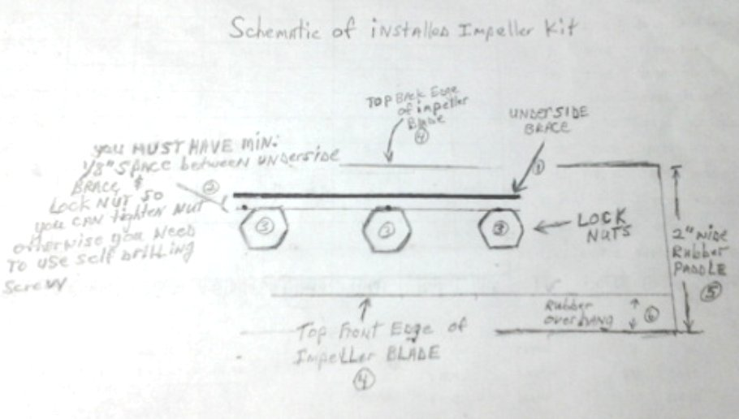
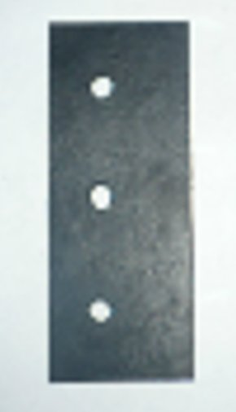
Single - SBR Rubber Paddle (No H/W) for our Snow Blower Impeller Kit ™
Made in the USA out of new, industrial grade materials, this item can be used as a spare or replacement
to the SBR paddles used in our kits. Model# SBIK140 (1/4”) & Model# SBIK380 (3/8”)
1/4" or 3/8” thick rubber paddle (2"W x 5"L)  - Made from Styrene Butadiene rubber (SBR rubber)  - SBR rubber with minimum tensile strength of 725 PSI (5 MPA)  - Shore A rubber with a durometer of 65-75  - Pre-punched mounting holes  * SBR Rubber paddle only, no H/W included | SBR Rubber Paddle for use with Snow Blower Impeller Kit™ models:  UPC MPN Desc  091037826305 SBIK141 1-blade 1/4” Regular Duty Kit  091037826312 SBIK143 3-blade 1/4” Regular Duty Kit  091037826329 SBIK144 4-blade 1/4” Regular Duty Kit  091037826336 SBIK145 5-blade 1/4” Regular Duty Kit  091037826404 SBIK146 6-blade 1/4” Regular Duty Kit  091037826343 SBIK381 1-Blade 3/8” Heavy Duty Kit  091037826350 SBIK383 3-blade 3/8” Heavy Duty Kit  091037826367 SBIK384 4-blade 3/8” Heavy Duty Kit  091037826374 SBIK385 5-blade 3/8” Heavy Duty Kit  091037826411 SBIK386 6-blade 3/8” Heavy Duty Kit
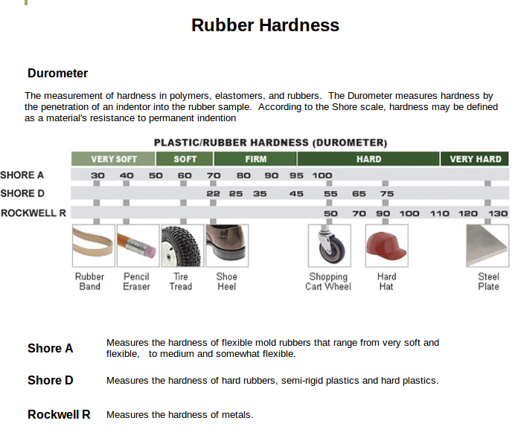

Thank You For Your Order! If you need more kits, go to our website at http://www.snowblowerimpellerkit.com™ or find us on EBay by searching for “Snow Blower Impeller Kit™”
© 2012 SnowBlowerImpellerKit.com™ All Rights Reserved Questions? Contact us at: info@SnowBlowerImpellerKit.com
Snow Blower Impeller Kit™ Reg. USPTO Read our FAQs on SnowBlowerImpellerKit.com

